Test Case: tc003_SPX_Dev5_Crear_Requisicion_Spot_Tipo_Cobro_CC_Urgent
Step 1 - Enter username and password and click to button Enter : Credentials Entered
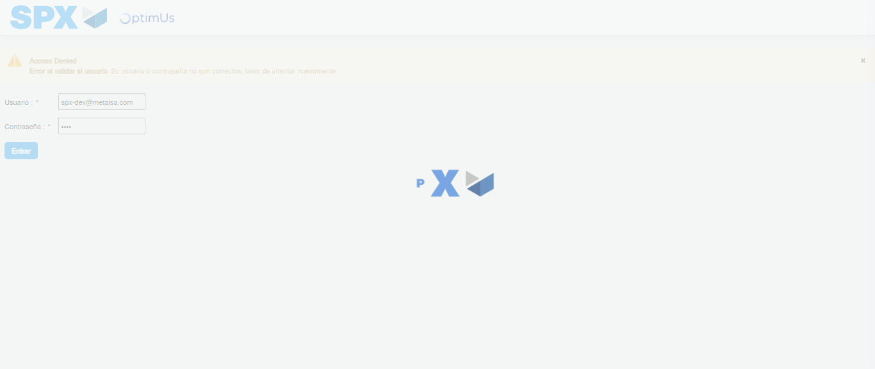Image file-name: QC_Testing-tc003_SPX_Dev5_Crear_Requisicion_Spot_Tipo_Cobro_CC_Urgent-1783358659039

Step 2 - Select to UEN and Access to Spot Buy Requisitions : UEN Correctly selected and Correct access
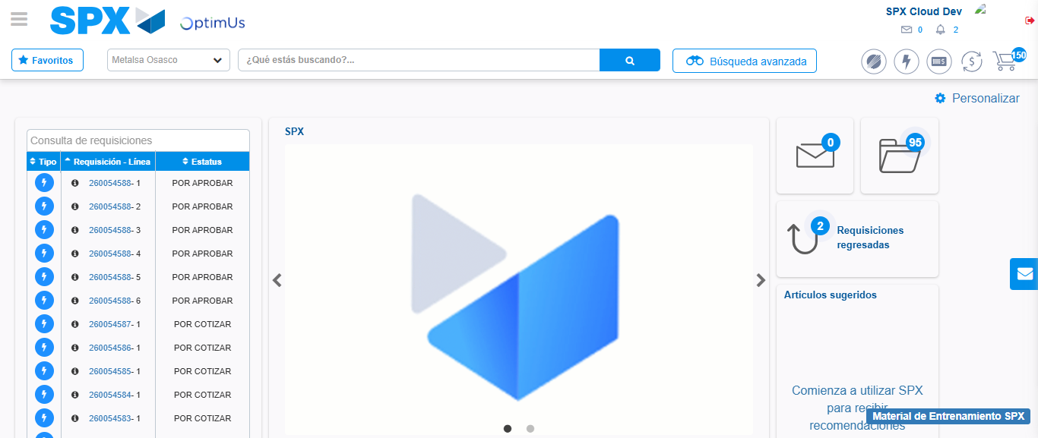Image file-name: QC_Testing-tc003_SPX_Dev5_Crear_Requisicion_Spot_Tipo_Cobro_CC_Urgent-1783358684513

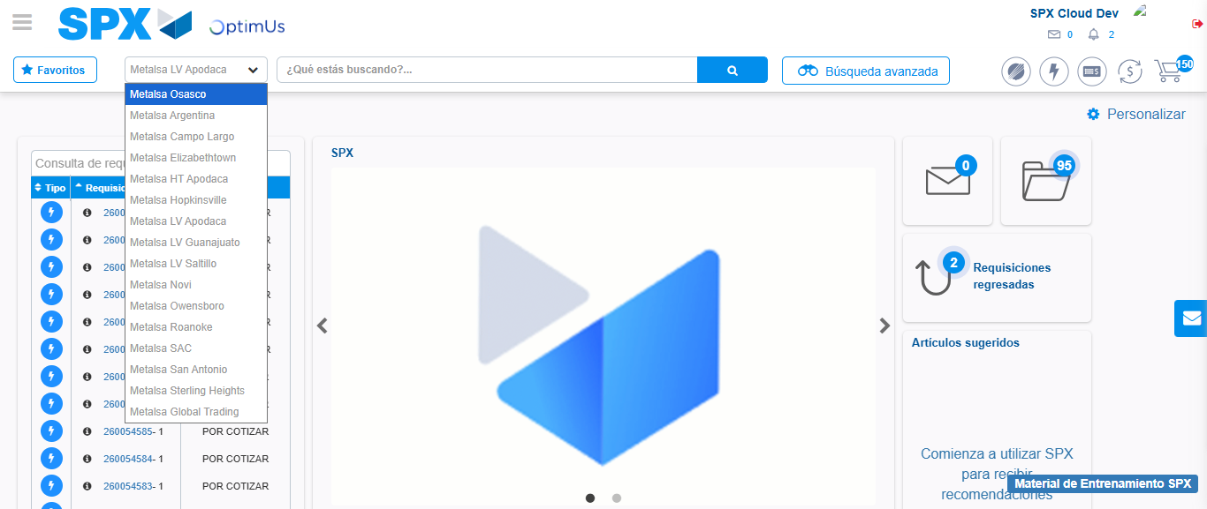Image file-name: QC_Testing-tc003_SPX_Dev5_Crear_Requisicion_Spot_Tipo_Cobro_CC_Urgent-1783358687345

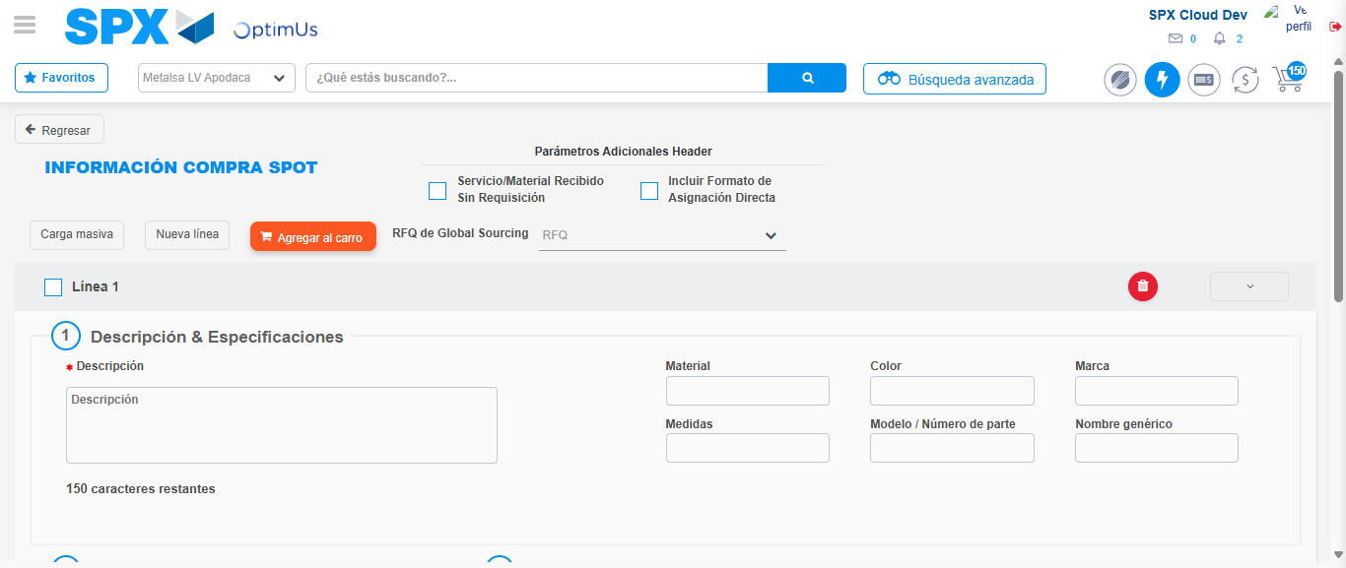Image file-name: QC_Testing-tc003_SPX_Dev5_Crear_Requisicion_Spot_Tipo_Cobro_CC_Urgent-1783358711430

Step 3 - Data Capture Spot Buy Requisition: Data captured correctly
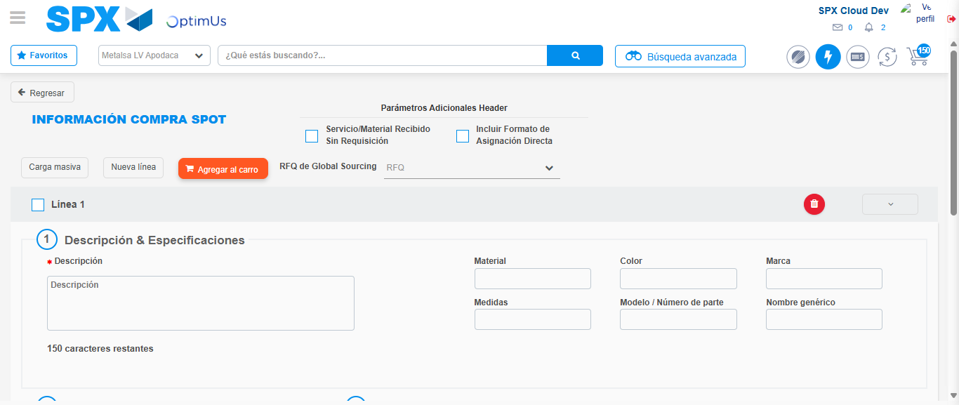Image file-name: QC_Testing-tc003_SPX_Dev5_Crear_Requisicion_Spot_Tipo_Cobro_CC_Urgent-1783358711698

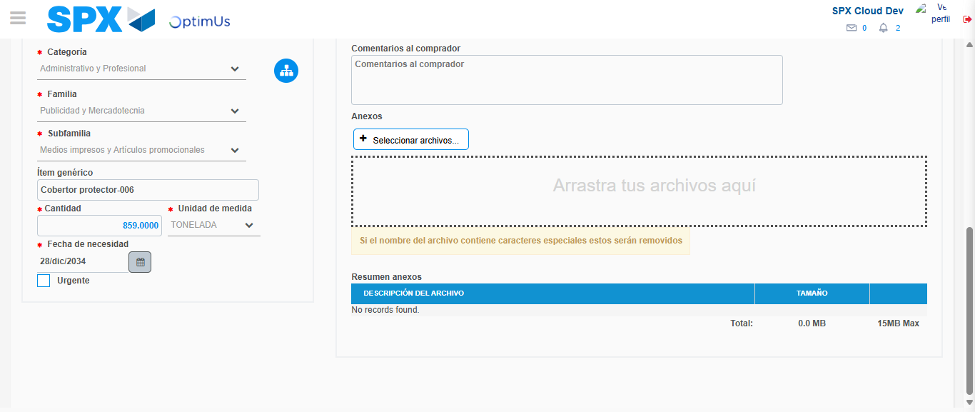Image file-name: QC_Testing-tc003_SPX_Dev5_Crear_Requisicion_Spot_Tipo_Cobro_CC_Urgent-1783358722115

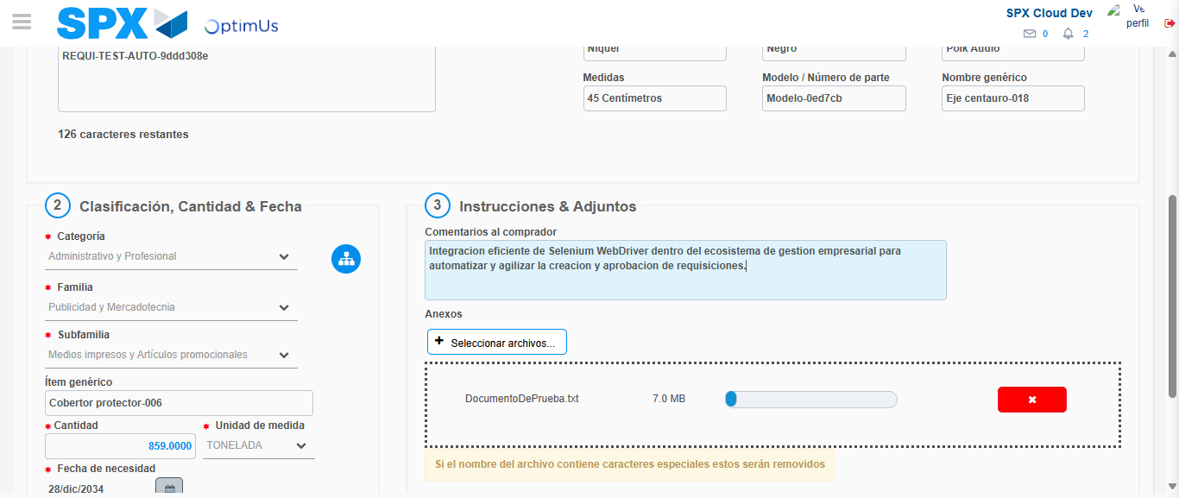Image file-name: QC_Testing-tc003_SPX_Dev5_Crear_Requisicion_Spot_Tipo_Cobro_CC_Urgent-1783358723054

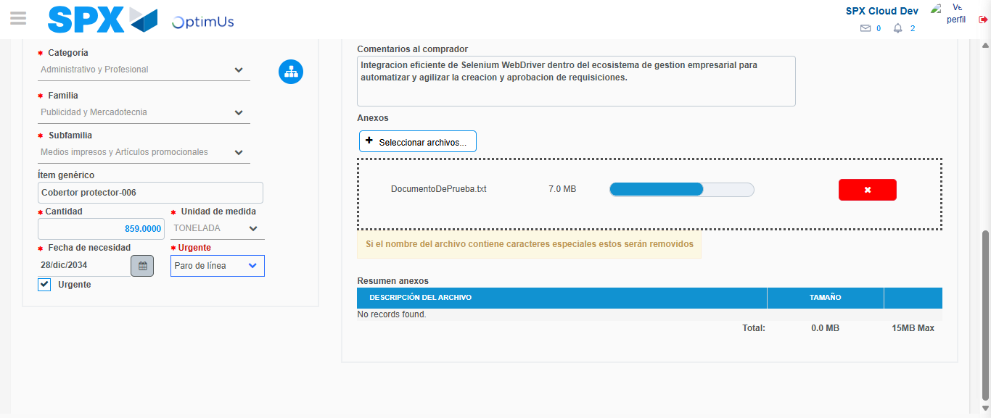Image file-name: QC_Testing-tc003_SPX_Dev5_Crear_Requisicion_Spot_Tipo_Cobro_CC_Urgent-1783358727024

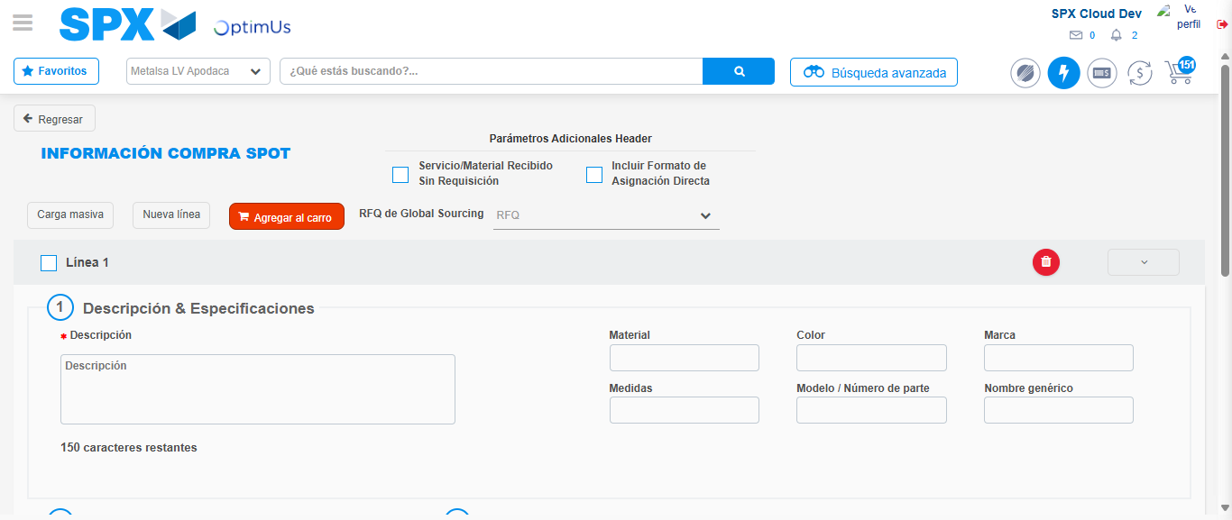Image file-name: QC_Testing-tc003_SPX_Dev5_Crear_Requisicion_Spot_Tipo_Cobro_CC_Urgent-1783358737768

Step 7 - Return to Main Page SPX : Return to Main Page SPX
Image file-name: QC_Testing-tc003_SPX_Dev5_Crear_Requisicion_Spot_Tipo_Cobro_CC_Urgent-1783358684513

Image file-name: QC_Testing-tc003_SPX_Dev5_Crear_Requisicion_Spot_Tipo_Cobro_CC_Urgent-1783358687345

Image file-name: QC_Testing-tc003_SPX_Dev5_Crear_Requisicion_Spot_Tipo_Cobro_CC_Urgent-1783358711430

Image file-name: QC_Testing-tc003_SPX_Dev5_Crear_Requisicion_Spot_Tipo_Cobro_CC_Urgent-1783358740032

Image file-name: QC_Testing-tc003_SPX_Dev5_Crear_Requisicion_Spot_Tipo_Cobro_CC_Urgent-1783358740234

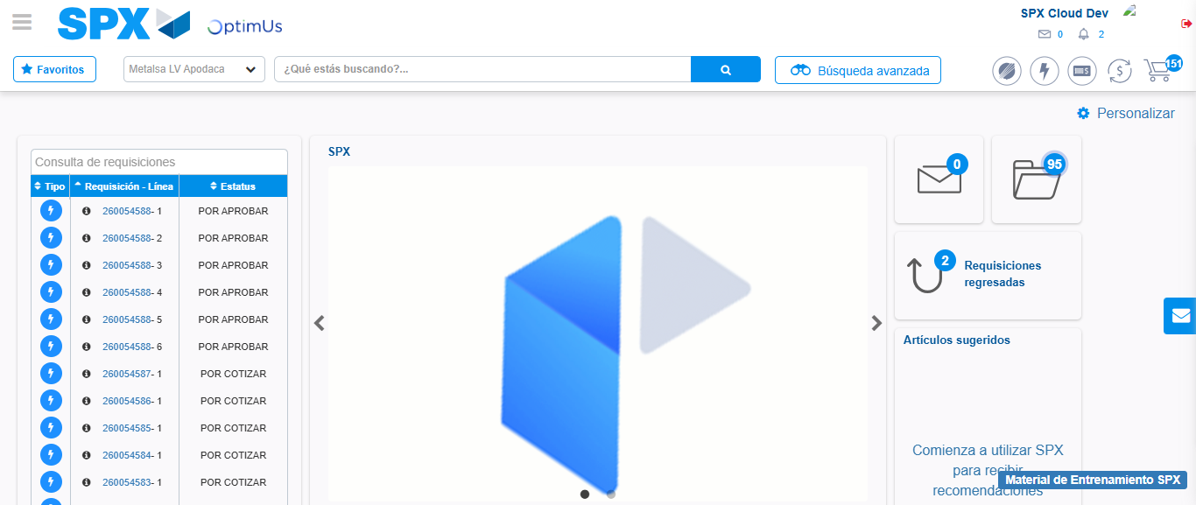Image file-name: QC_Testing-tc003_SPX_Dev5_Crear_Requisicion_Spot_Tipo_Cobro_CC_Urgent-1783358761761

Step 8 - Log Out : Log Out SPX
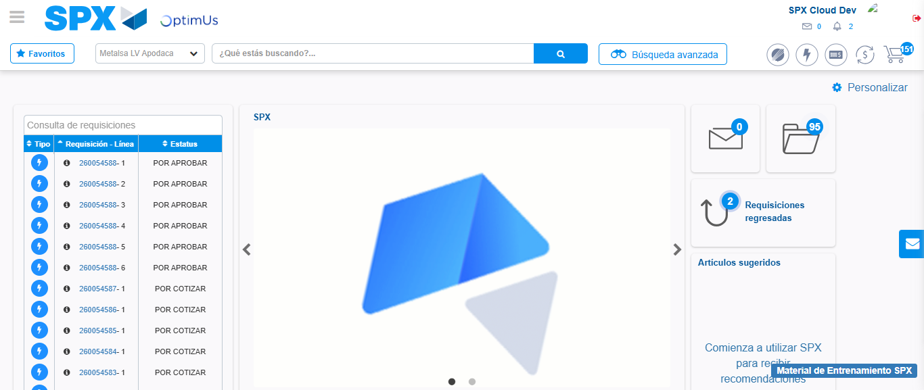Image file-name: QC_Testing-tc003_SPX_Dev5_Crear_Requisicion_Spot_Tipo_Cobro_CC_Urgent-1783358762094

